Ficus Series Development Board Pinout Definition Table
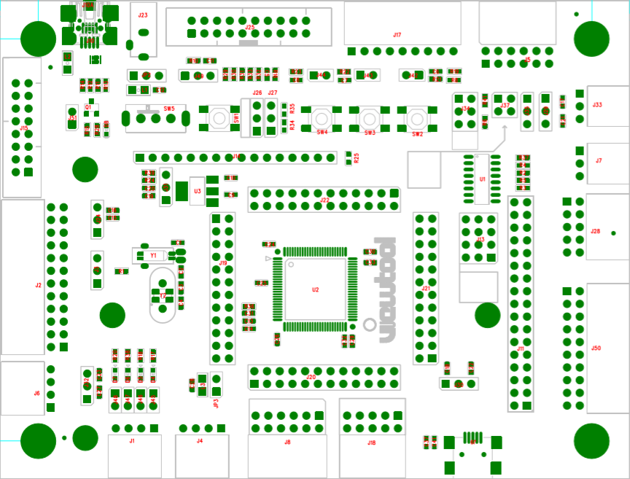

Ficus J15 Pinout Functionality Definition(External LED & GPIO)
GPIO | Pin Name | Pin Number |  | Pin Name | GPIO
 | GND | 1 | 2 | P1 | GPIOE_5
 | GND | 3 | 4 | P2 | GPIOE_6
 | GND | 5 | 6 | P3 | GPIOC_13
GPIOE_2 | P4 | 7 | 8 | P5 | GPIOC_0
GPIOC_1 | P6 | 9 | 10 | P7 | GPIOA_2
GPIOC_2 | P8 | 11 | 12 | P9 | GPIOA_3
 | GND | 13 | 14 | P10 | GPIOE_3
 | GND | 15 | 16 | P11 | GPIOE_4

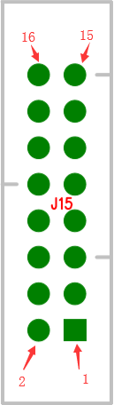

Ficus J2 Pinout Functionality Definition(External Ethernet & GPIO)
GPIO | Pin Name | Pin Number |  | Pin Name | GPIO
GPIOA_0 | P1 | 1 | 2 | P2 | GPIOB_11
GPIOA_3 | P3 | 3 | 4 | P3 | GPIOB_12
GPIOA_1 | P5 | 5 | 6 | P6 | GPIOB_13
GPIOB_1 | P7 | 7 | 8 | P8 | GPIOC_4
GPIOB_0 | P9 | 9 | 10 | P10 | GPIOC_5
GPIOB_8 | P11 | 11 | 12 | P12 | GPIOC_1
GPIOC_2 | P13 | 13 | 14 | P14 | GPIOA_2
GPIOC_3 | P15 | 15 | 16 | P16 | GPIOB_10
GPIOD_2 | P17 | 17 | 18 | P18 | GPIOA_7
GPIOD_3 | P19 | 19 | 20 | P20 | GPIOB_5
 | 3.3V | 21 | 22 | 3.3V
 | GND | 23 | 24 | GND

Pinout number defintion：
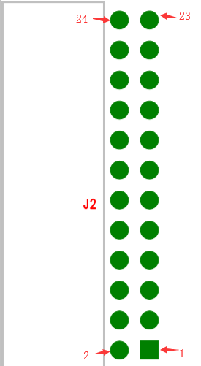

Ficus J6 Pinout Functionality Definition(UART & GPIO & Software I2C)
Pin Number | Pin Name | GPIO | UART | S_I2C
1 | P1 | GPIOA_2 | UART2_TX | S_I2C1_SCL
2 | P2 | GPIOA_3 | UART2_RX | S_I2C1_SDA
3 | GND
4 | 3.3V

Pinout number defintion：
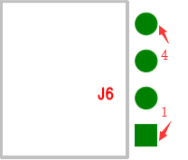

Ficus J1 Pinout Functionality Definition(CAN & GPIO)
Pin Number | Pin Name | GPIO | CAN
1 | 3.3V
2 | GND
3 | P1 | GPIOB_8 | CAN0_RX
4 | P2 | GPIOB_9 | CAN0_TX

Pinout number defintion：
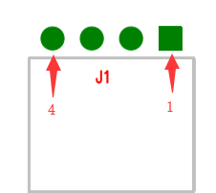

Ficus J4 Pinout Functionality Definition(CAN & GPIO)
Pin Number | Pin Name | GPIO | CAN
1 | 3.3V
2 | GND
3 | P1 | GPIOB_12 | CAN1_RX
4 | P2 | GPIOB_13 | CAN1_TX

Pinout number defintion：
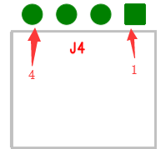
Ficus J8 Pinout Functionality Definition(SPI & GPIO)
SPI | GPIO | Pin Name | Pin Number |  | Pin Name | GPIO | SPI
 |  | 3.3V | 1 | 7 | 3.3V
 |  | GND | 2 | 8 | GND
SPI1_MISO | GPIOC_11 | P1 | 3 | 9 | P2 | GPIOA_6 | SPI0_MISO
SPI1_MOSI | GPIOC_12 | P3 | 4 | 10 | P4 | GPIOA_7 | SPI0_MOSI
SPI1_CLK | GPIOC_10 | P5 | 5 | 11 | P6 | GPIOB_3 | SPI0_CLK
SPI1_NSS | GPIOA_15 | P6 | 6 | 12 | P8 | GPIOA_4 | SPI0_NSS

Pinout number defintion：
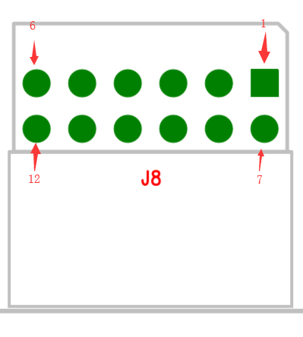
Ficus J18 Pinout Functionality Definition(PWM & DAC & CNT & ADC & GPIO & Software I2C)
CNT | S_I2C | DAC | ADC | PWM | GPIO | Pin Name | Pin Number |  | Pin Name | GPIO | PWM | ADC | CNT | S_I2C
 |  |  |  |  |  | 3.3V | 1 | 2 | 5V
 |  |  |  |  |  | GND | 3 | 4 | GND
 | S_I2C2_SCL | DAC_CH0 | ADC_CH4 |  | GPIOA_4 | P1 | 5 | 6 | P2 | GPIOC_5
 | S_I2C2_SDA | DAC_CH1 | ADC_CH5 |  | GPIOA_5 | P3 | 7 | 8 | P4 | GPIOA_1 | PWM_CH1 | ADC_CH1 | CNT_CH1 | S_I2C0_SDA
CNT_CH2 |  |  | ADC_CH6 | PWM_CH4 | GPIOA_6 | P5 | 9 | 10 | P6 | GPIOA_0 | PWM_CH0 | ADC_CH0 | CNT_CH0 | S_I2C0_SCL

Pinout number defintion：
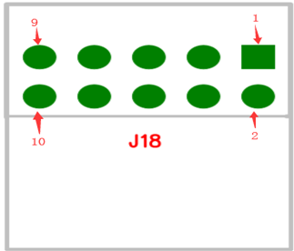
Ficus J7 Pinout Functionality Definition(GPIO)
Pin Number | Pin Name | GPIO
1 | 3.3V
2 | P1 | GPIOC_3
3 | GND

Pinout number defintion：
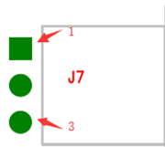
Ficus J50 Pinout Functionality Definition(SRAM NAND & GPIO)
GPIO | Pin Name | Pin Number |  | Pin Name | GPIO
 | 3.3V | 1 | 2 | 3.3V
 | GND | 3 | 4 | GND
GPIOD_14 | P1 | 5 | 6 | P2
GPIOD_15 | P3 | 7 | 8 | P4 | GPIOD_4
GPIOD_0 | P5 | 9 | 10 | P6 | GPIOD_5
GPIOD_1 | P7 | 11 | 12 | P8 | GPIOD_6
GPIOE_7 | P9 | 13 | 14 | P10 | GPIOD_11
GPIOE_8 | P11 | 15 | 16 | P12 | GPIOD_12
GPIOE_9 | P13 | 17 | 18 | P14 | GPIOE_12
GPIOE_10 | P15 | 19 | 20 | P16 | GPIOE_11

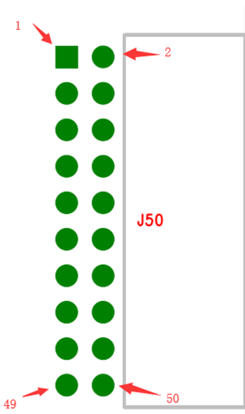

Ficus J28 Pinout Functionality Definition(Hardware I2C & GPIO)
H_I2C | GPIO | Pin Name | Pin Number |  | Pin Name | GPIO | H_I2C
 |  | 3.3V | 1 | 2 | 3.3V
 |  | GND | 3 | 4 | GND
HI2C1_SDA | GPIOB_11 | P1 | 5 | 6 | P2 | GPIOB_7 | HI2C0_SDA
HI2C2_SCL | GPIOB_10 | P3 | 7 | 8 | P4 | GPIOB_6 | HI2C0_SCL
HI2C2_SMBA | GPIOB_12 | P5 | 9 | 10 | P6 | GPIOB_5 | HI2C0_SMBA

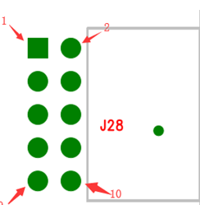

Ficus J33 Pinout Functionality Definition(GPIO)
Pin Number | Pin Name | GPIO
1 | 3.3V
2 | P1 | GPIOC_3
3 | GND

Pinout number defintion：
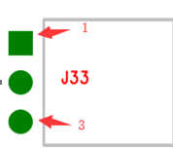

Ficus J5 Pinout Functionality Definition(USART)
GPIO | Pin Name | Pin Number |  | Pin Name | GPIO
GPIOA_11 | P1 | 1 | 2 | 3.3/5V
GPIOA_9 | P2 | 3 | 4 | GND
GPIOA_10 | P3 | 5 | 6 | P4 | GPIOB_5
 | 3.3/5V | 7 | 8 | P5 | GPIOB_3
GPIOA_12 | P7 | 9 | 10 | P6 | GPIOA_15
 | GND | 11 | 12 | P8 | GPIOC_7

Pinout number defintion：
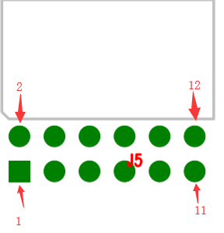
Power choose 3.3V/5V

J37 is Switch Connect GPIOA_9 and GPIOA_10
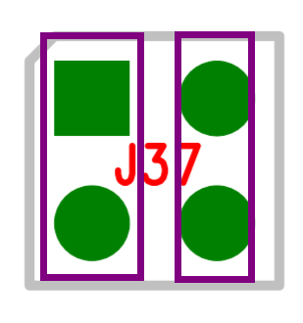

Ficus J17 Pinout Functionality Definition(SDIO & GPIO)
Pin Number | Pin Name | GPIO
1 | 3.3V
2 | GND
3 | P1 | GPIOC_8
4 | P2 | GPIOD_2
5 | P3 | GPIOC_12
6 | P4 | GPIOC_11
7 | P5 | GPIOC_10
8 | P6 | GPIOC_0
9 | P7 | GPIOA_8

Pinout number defintion：
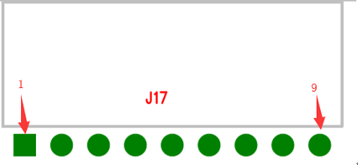

Ficus J25 Pinout Functionality Definition
JTAG | Pin Name | Pin Number |  | Pin Name
 | 3.3V | 1 | 2 | 3.3V
TRST | P1 | 3 | 4 | GND
TDI | P2 | 5 | 6 | GND
TMS | P3 | 7 | 8 | GND
TCK | P4 | 9 | 10 | GND
 |  | 11 | 12 | GND
TDO | P5 | 13 | 14 | GND
NRESET | P6 | 15 | 16 | GND
 |  | 17 | 18 | GND
 |  | 19 | 20 | GND

Pinout number defintion：
